The question has come up a couple of times on how to associate Property Definitions with a Category. So I thought I would write up the code and post it here.
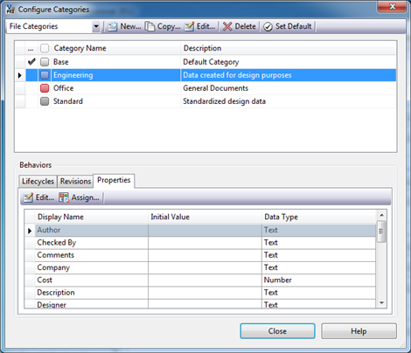
The code is a bit hard to follow unless you understand a few things about Categories. A Category is a behavior that is a container for other behaviors. Things like property definitions, lifecycles and revision schemes can be thought of as living inside a category or set of categories. So in the case of properties, we are adding a new property definition to a Category’s collection of behaviors. So a lot of the code deals with Behavior objects, which is an abstract representation of our property definition. The good news is that the code below can easily be re-purposed to associate revisions and lifecycles to a Category.
In this example code, I’m going to take a UDP I created, MyProp, and associate it to the Engineering category.
// C#
private void UpdateCategoryProperties(WebServiceManager mgr)
{
Cat [] categories =
mgr.CategoryService.GetCategoriesByEntityClassId("FILE", true);
Cat engineeringCat = categories.SingleOrDefault(
n => n.SysName == "Engineering");

CatCfg catCfg = mgr.CategoryService.GetCategoryConfigurationById(
engineeringCat.Id, new string[] { "UserDefinedProperty" });

IEnumerable<long> propDefIds = catCfg.BhvCfgArray[0].BhvArray.Select(
n => n.Id);

PropDef[] props =
mgr.PropertyService.GetPropertyDefinitionsByEntityClassId("FILE");
PropDef myProp = props.SingleOrDefault(n => n.DispName == "MyProp");
if (propDefIds.Contains(myProp.Id))
return; // the property is already hooked to the category

long [] propDefArray = propDefIds.Concat(
new long [] {myProp.Id}).ToArray();
BehaviorAssignmentType [] typeArray = propDefArray.Select(
n => BehaviorAssignmentType.Default).ToArray();

mgr.CategoryService.UpdateCategoryBehaviorAssignmentTypes(
engineeringCat.Id,"UserDefinedProperty", AllowNoBehavior.Yes,
propDefArray, typeArray, true);
}

' VB.NET
Private Sub UpdateCategoryProperties(mgr As WebServiceManager)
Dim categories As Cat() = _
mgr.CategoryService.GetCategoriesByEntityClassId("FILE", True)
Dim engineeringCat As Cat = categories.SingleOrDefault( _
Function(n) n.SysName = "Engineering")

Dim catCfg As CatCfg = _
mgr.CategoryService.GetCategoryConfigurationById( _
engineeringCat.Id, New String() {"UserDefinedProperty"})

Dim propDefIds As IEnumerable(Of Long) = _
catCfg.BhvCfgArray(0).BhvArray.[Select](Function(n) n.Id)

Dim props As PropDef() = _
mgr.PropertyService.GetPropertyDefinitionsByEntityClassId("FILE")
Dim myProp As PropDef = props.SingleOrDefault( _
Function(n) n.DispName = "MyProp")
If propDefIds.Contains(myProp.Id) Then
Return ' the property is already hooked to the category
End If

Dim propDefArray As Long() = _
propDefIds.Concat(New Long() {myProp.Id}).ToArray()
Dim typeArray As BehaviorAssignmentType() = _
propDefArray.[Select](Function(n) BehaviorAssignmentType.[Default]).ToArray()

mgr.CategoryService.UpdateCategoryBehaviorAssignmentTypes( _
engineeringCat.Id, "UserDefinedProperty", _
AllowNoBehavior.Yes, propDefArray, typeArray, True)
End Sub

After I ran the code, my Engineering category looked like this.
